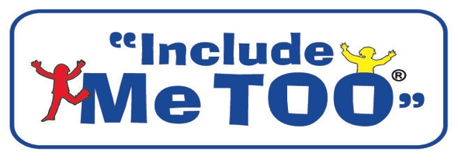
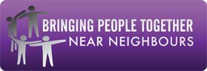

REPLY SLIP

Shared Values, Faith and Disability National Seminar
Tuesday 8th April 2014
9.30am – 3.30pm
At Nishkam Centre, 6 Soho Road, Handsworth, Birmingham, B21 9BH

Name of Organisation/Group:

Your Name:

Your Role:

Address:

Postcode:

Telephone Details:

Email Address:

Are you providing a information stall?

Yes No

Only complete this section if you are providing a stall

If you are providing a information stall at the seminar there is charge of £25

Please complete the following information

Payment
□ I enclose a cheque for £ made payable to Include Me TOO
□ Please invoice me for £ at the address above/at the following address (delete as appropriate).

Invoice address:

Name .

Address

Postcode

Please complete this form and forward to
Chris Whiles, Include Me TOO,
Newhampton Arts Centre, Dunkley Street,Wolverhampton, West Midlands WV1 4AN
Telephone 01902 711604 / 01902 399888 Email chris@includemetoo.org.uk

Closing date for booking places is Friday 21st March 2014
THANK YOU

