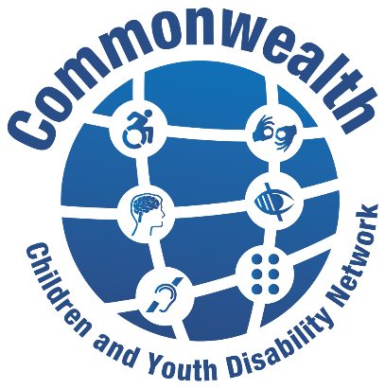

The Commonwealth Children and Youth Disability Network (CCYDN) is a disabled youth led network (including those who work with, or have set up, YDPO’s / DPOs / OPD’s or NGO’s working with disabled children and young people) whose mission is to:

CCYDN is the official disability thematic Commonwealth Youth network and the first to include children advocacy and inclusion.
CCYDN provides a platform for disabled youth to connect, share learning and ideas, develop leadership and advocacy skills and knowledge to influence on disability rights, inclusion UNCRC and UNCRPD implementation at national, regional levels throughout the Commonwealth.

CCYDN represents a strong united voice of disabled children and young people across the Commonwealth, increasing our collective representation and recognition in all our roles as key actors, leaders, and advocates for positive change necessary in achieving disability rights, equity and better inclusive futures for all.

Individual Membership

Individual membership is open to disabled young people aged between 13 years and 35 years. If you are a sibling aged under 35 years with a disabled brother or sister also aged under 35 years and wish to join, please send an email to ccydn@includemetoo.org.uk

- Your full name:

- Nationality

- Country of residence:

- Age
Date of Birth

- Contact details:
Phone Number (with country code):
Facebook/Twitter and other social media sites:
Email address:
WhatsApp Mobile Number (Please include + Country Code):
Contact number (Please include + Country Code):
*Whatsapp and Email are mandatory fields so that we can best keep you informed with CCYDN updates that will be relevant to your region.

- Gender
Female
Male
Other Please specify ,,,,,,,,,,,,,,,,,,,,,,,,,,,,,,,,,,,,,,,,,,,
Prefer not to specify

- What type(s) of disability do you identify as having?
Tick √ all that apply and provide details and any relevant links
Blind / Vision Impaired

Deaf / Hard of hearing

Deafblindness

Physical disability

Chronic Illness

Intellectual or cognitive disability

Neurodiversity (E.g. Autism, ADHD)

Other

Please provide any additional details of your disability?

- Are you a member of Youth Disabled Persons Organisation (YDPO), Disabled Persons Organisation (DPO), Organisation of Persons with Disabilities (OPD), Non Governmental Organisation (NGO), disability related groups, networks or forums?
Yes
No

If you answered yes please list them below, your position in organisation, role and responsibility and indicate which of these are youth led.

- Have you been involved in any work promoting disability rights, inclusion and participation of disabled children and young people?

- Have you been involved in any work promoting disability rights, inclusion and participation of disabled children and young people?
Tick √ all that apply and provide details and any relevant links
Self-Advocacy
Organisation
Other Please provide details

- What issues are you passionate about or interested in supporting for children and young people’s disability rights, inclusion, participation and representation?

- Commonwealth Children & Youth Disability Network (CCYDN) Theme Groups
Members of CCYDN can get involved in this work sharing their views, getting involved in campaigns, thematic working groups and take action as disability rights defenders and inclusive changemakers in their countries and local communities.
If you would like to get involved please tick up to 3 themes you would like to be involved in, support advocacy, delivery and have your say.
Tick √ upto 3 all which apply
Inclusive Education, Lifelong Learning

Economic Empowerment and Employment

Gender Equality – Women and Girls with Disabilities

Ending Stigma, and Taboos associated with disabilities

Safeguarding from all forms abuse and harmful practices

Humanitarian action and climate change

Inclusive health and social care

Inclusive Sport and Recreation

- What skills and experience do you have on the work theme(s) you have chosen?
You can also provide links and any examples here

- Do you have other skills, experience or attributes that you feel would assist and benefit CCYDN? Can you give provide details

I have read and agree to have my data stored as set in the privacy notice. <https://includemetoo.org.uk/privacy-notice/> Tick √ to confirm here __________

If you are under the age of 18 years old we will need your parents’ or guardians’ details and consent for you to share the details you have provided in this membership form:
Full Name:
Relationship to membership applicant:
Email Address:

Email completed membership form to ccydn@includemetoo.org.uk

