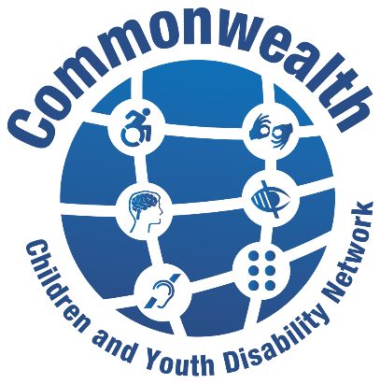

The Commonwealth Children and Youth Disability Network (CCYDN) is a disabled youth led network (including those who work with, or have set up, YDPO’s / DPOs / OPD’s or NGO’s working with disabled children and young people) whose mission is to:

CCYDN is the official disability thematic Commonwealth Youth network and the first to include children advocacy and inclusion.
CCYDN provides a platform for disabled youth to connect, share learning and ideas, develop leadership and advocacy skills and knowledge to influence on disability rights, inclusion UNCRC and UNCRPD implementation at national, regional levels throughout the Commonwealth.

CCYDN represents a strong united voice of disabled children and young people across the Commonwealth, increasing our collective representation and recognition in all our roles as key actors, leaders, and advocates for positive change necessary in achieving disability rights, equity and better inclusive futures for all.

Organisation Membership

1: Name of organisation:

2: Postal Address:

3: Country your organisation operates in:

4: Website/Facebook/Twitter and other social media sites of your organisation:

5: Name of contact person:

6: Position of the contact person within your organisation:

7: Email of the contact person:

8: Phone number of the contact person (with country code):

9: Is your organisation officially registered?
Yes
No

10: Please confirm which of the following applies to your organisation:
Youth led Disabled People’s Organisation (YDPO)
Non-Government Organisation supporting disabled children and young people (NGO)
Disabled People’s Organisation supporting disabled children and young people (DPO)

11: What range of additional needs and impairments are supported by your organisation in regards to disabled children and young people?

12a: At which level is your organisation active? (select all which apply)
Local
Regional
National
International

12b: Can you provide details of your organisation’s main areas of work?

13: How does your organisation support the participation, inclusion and rights of disabled children and young people?

14: Will you be supporting disabled children and young people to join CCYDN as representatives on behalf of your organisation?
Yes
No

15: Have you signed up to the Global Disability Children and Young People’s Charter 2022?
Yes
No

16: If you answered no would be you interested to support and advocate for the 16 commitments in the Global Disability Children and Young People’s Charter and receive details how to sign up, and support?
Yes
No

I have read and agree to have my data stored as set in the privacy notice. <https://includemetoo.org.uk/privacy-notice/> Tick √ to confirm here __________

Email completed membership form to ccydn@includemetoo.org.uk

